Task 1: Launching My EC2 Instance
In this task, I launched an Amazon EC2 instance with termination protection enabled. Termination protection helps prevent me from accidentally terminating the EC2 instance. I deployed the instance with a User Data script that allowed me to set up a simple web server.
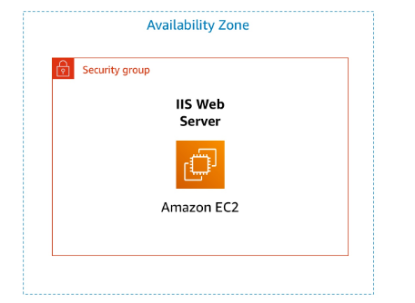

Step 1: Naming My EC2 Instance
When I named my instance, AWS automatically created a key-value pair. The key was Name, and the web server was the name I entered for my EC2 instance.
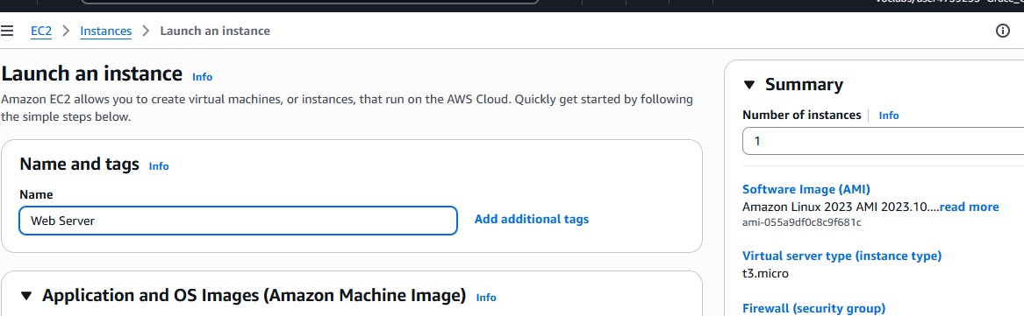

Step 2: Choosing an Amazon Machine Image (AMI)
I selected an Amazon Machine Image (AMI), which provides the information required to launch an instance (a virtual server in the cloud). The AMI included:
- A template for the root volume, such as the operating system or application server
- Launch permissions that control which AWS accounts can use the AMI
- A block device mapping that specifies the volumes to attach when the instance is launched
I used an AMI from the Quick Start list, which contains the most commonly used AMIs. I noted that it is also possible to create a custom AMI or choose one from the AWS Marketplace.
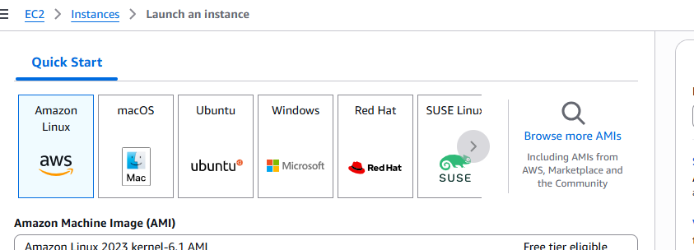

Step 3: Choosing an Instance Type
I chose a t3.micro instance type. Amazon EC2 offers a wide variety of instance types optimized for different use cases, with varying CPU, memory, storage, and networking capabilities. The t3.micro instance provides 2 virtual CPUs and 1 GiB of memory, which was suitable for this lab.
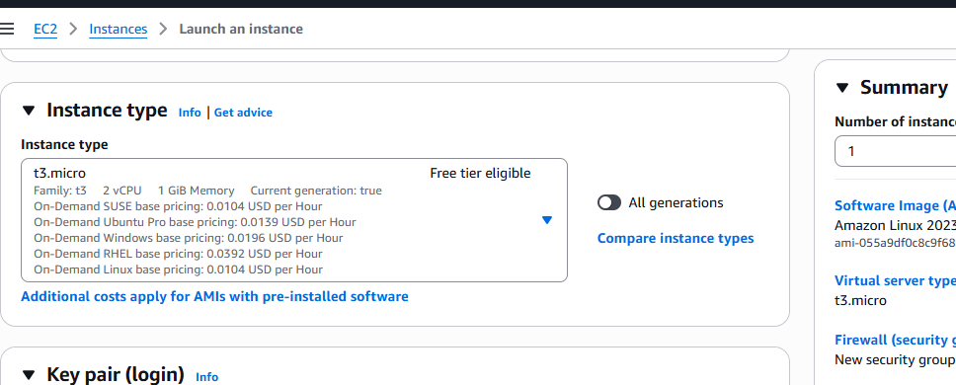

Step 4: Configuring a Key Pair
Amazon EC2 uses public-key cryptography to secure login information. Normally, a key pair is required to log in to an instance. However, in this lab I did not need to log in to the instance, so I did not configure a key pair.
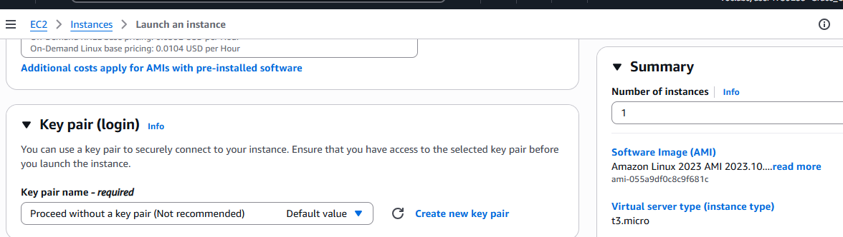

Step 5: Configuring the Network Settings
I configured the networking settings by selecting a Virtual Private Cloud (VPC), which determines where the instance is launched. I also configured a security group, which acts as a virtual firewall to control inbound and outbound traffic for the instance.
Since I was not required to log in using SSH, I removed SSH access to improve the security of the instance.
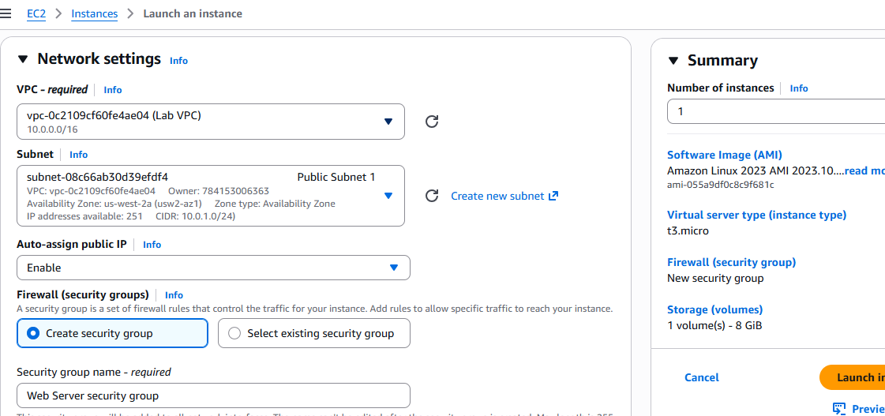

Step 6: Adding Storage
I used Amazon Elastic Block Store (Amazon EBS) for storage. The EC2 instance was launched with the default 8 GiB disk volume, which served as the root (boot) volume.
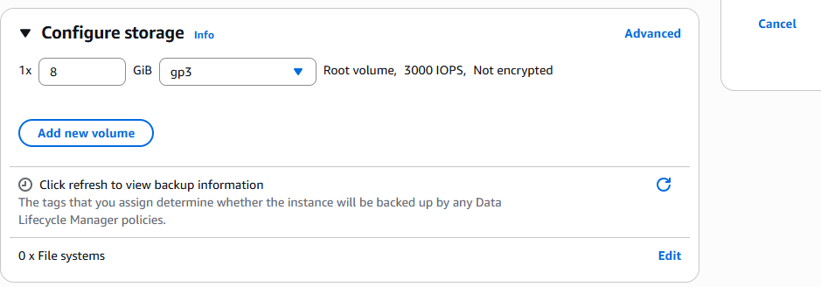

Step 7: Configuring Advanced Details
I configured advanced details by adding a User Data script. This script ran automatically after the instance started and installed a web server:
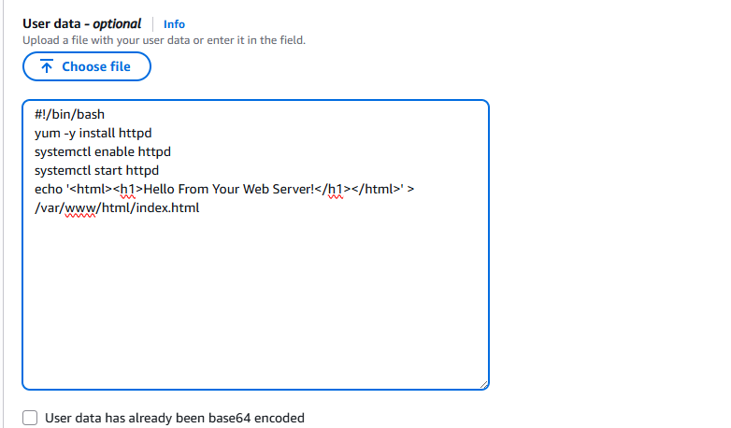

Step 8: Launching the EC2 Instance
After configuring all the settings, I launched the EC2 instance. The instance initially appeared in a Pending state and then changed to Running, indicating that it had started successfully. After a short time, the instance was accessible and received a public DNS name that could be used to reach it from the Internet.
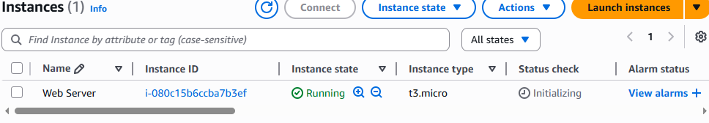

Task 2: Monitoring My Instance
Monitoring is an important part of maintaining the reliability, availability, and performance of Amazon EC2 instances. I used instance status monitoring to check whether Amazon EC2 detected any issues that could affect the instance.
Amazon EC2 performs automated hardware and software checks on every running instance. I viewed Amazon CloudWatch metrics for the instance, although only limited metrics were available because the instance had just been launched. I was able to select individual graphs to view expanded details.
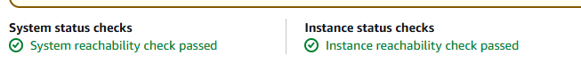
By default, basic monitoring (five-minute intervals) was enabled, with the option to enable detailed (one-minute) monitoring. I also reviewed the instance console screenshot feature, which allows troubleshooting if SSH or RDP access is unavailable.
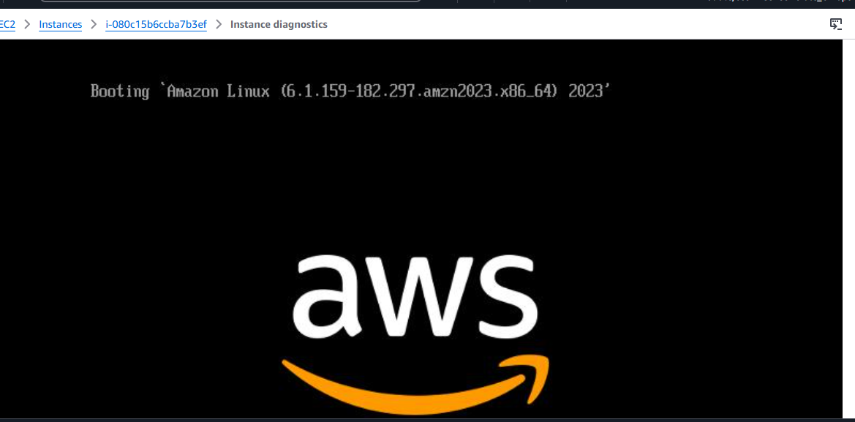

Task 3: Updating My Security Group and Accessing the Web Server
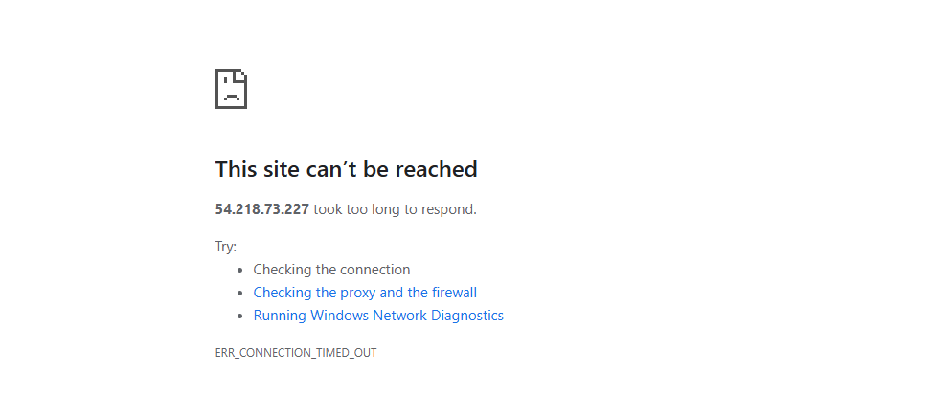
When I launched the EC2 instance, the User Data script installed a web server and created a simple web page. Initially, I could not access the web server because the security group did not allow inbound traffic on port 80 (HTTP). This demonstrated how security groups function as firewalls to control network traffic.

After updating the security group to allow HTTP traffic, I was able to access the web server and view the message:
“Hello From Your Web Server!”
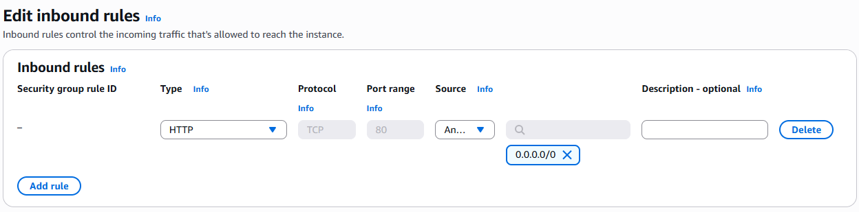

Task 4: Resizing My Instance (Instance Type and EBS Volume)
As requirements change, an EC2 instance may become over-utilized or under-utilized. To address this, I resized my instance.
Stopping the Instance
Before resizing, I stopped the instance. While there is no charge for a stopped EC2 instance, storage charges for attached EBS volumes continue.
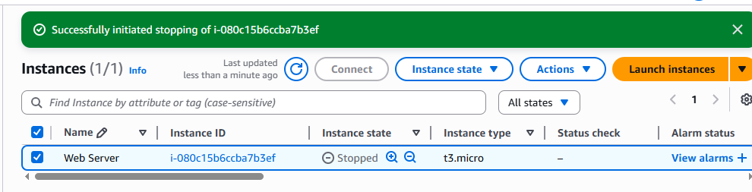

Changing the Instance Type
I changed the instance type from t3.micro to t3.small, which provides twice as much memory. I noted that the lab environment restricted the use of certain instance types.
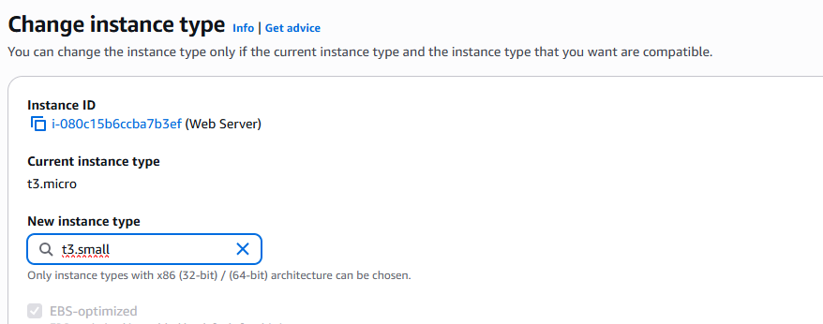
Resize the EBS Volume
I resized the disk volume from size of 8 GiB to 10 GiB
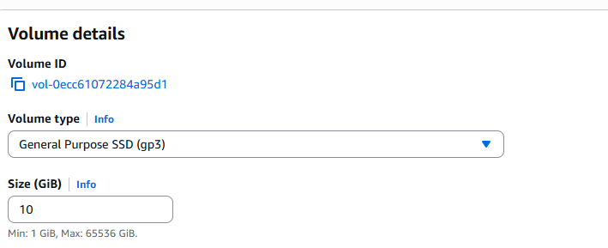

Starting the Resized Instance
I restarted the instance, which now had increased memory and disk capacity.
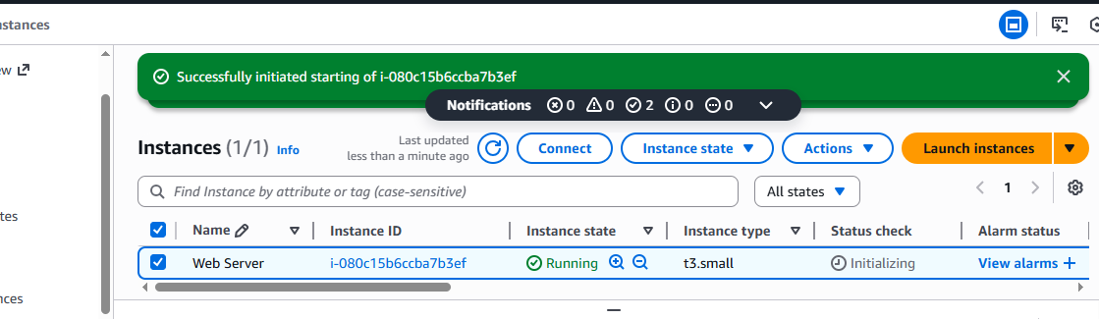

Task 5: Testing Termination Protection
When I attempted to terminate the instance, a warning message appeared explaining that the root EBS volume would be deleted upon termination. Although I selected the Terminate option, the instance did not terminate. Instead, an error message appeared stating that the instance could not be terminated. This occurred because termination protection was enabled on the instance.
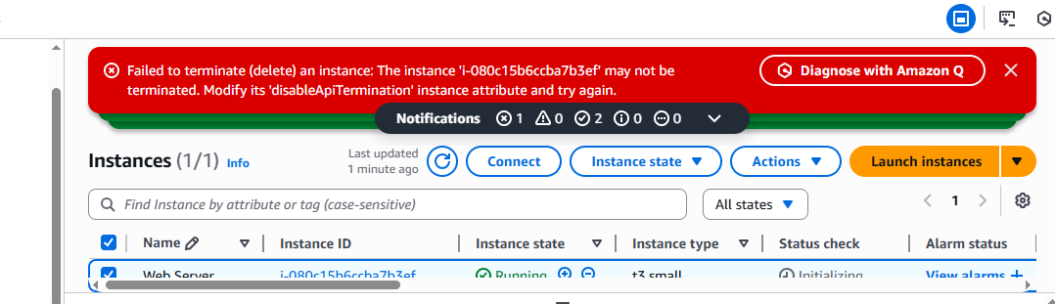

When an EC2 instance is no longer needed, it can be terminated. Termination permanently deletes the instance, and it cannot be restarted or accessed afterward.
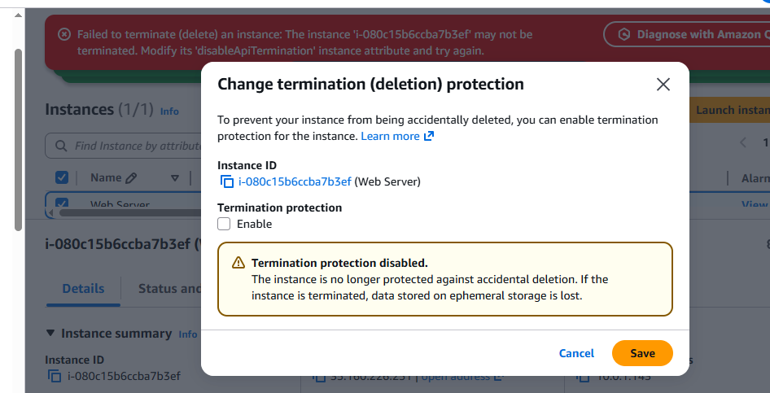
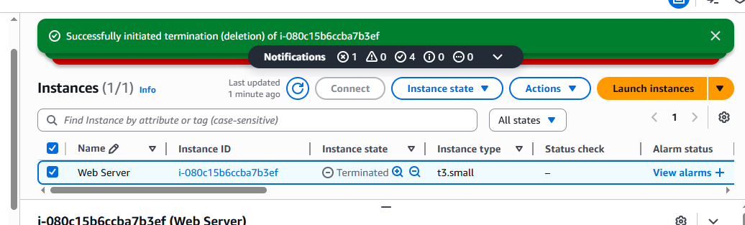

By the end of this lab, I was able to:
- Launch a web server with termination protection enabled
- Monitor my EC2 instance
- Modify the security group used by my web server to allow HTTP access
- Resize my Amazon EC2 instance to scale resources
- Test termination protection
- Terminate my EC2 instance

